Week 3
Confusion matrix :
tn, fp, fn, tp

Precision=accuracy
Recall = sensitivity
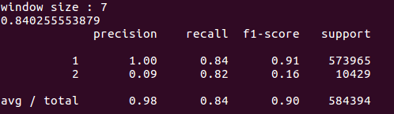
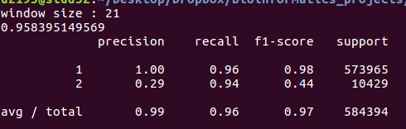
Classification report of confusion matrix:

